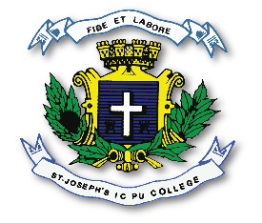
ST. JOSEPH’S INDIAN COMPOSITE PU COLLEGE
#23, Vittal Mallya Road, Bangalore – 560001.

SUBJECT: ELECTRONICS (40)
II PUC
SYLLABUS FOR I TEST – 2023-24

Chapters - 1. Field Effect Transistor (FET),
2. Bipolar Junction Transistor (BJT) Biasing,
3. Transistor Amplifiers,
10. Digital Electronics.

